**Project Name: Hexagonal Hive**

**By: Brenden Deutschman and Edgar Tejada**

How candles used to be made:

[Making Candles The Old Fashioned Way](https://www.youtube.com/watch?v=vNeAXr0PisM&t=163s)

<https://www.youtube.com/watch?v=vNeAXr0PisM&t=163s>

The Modern Solution:

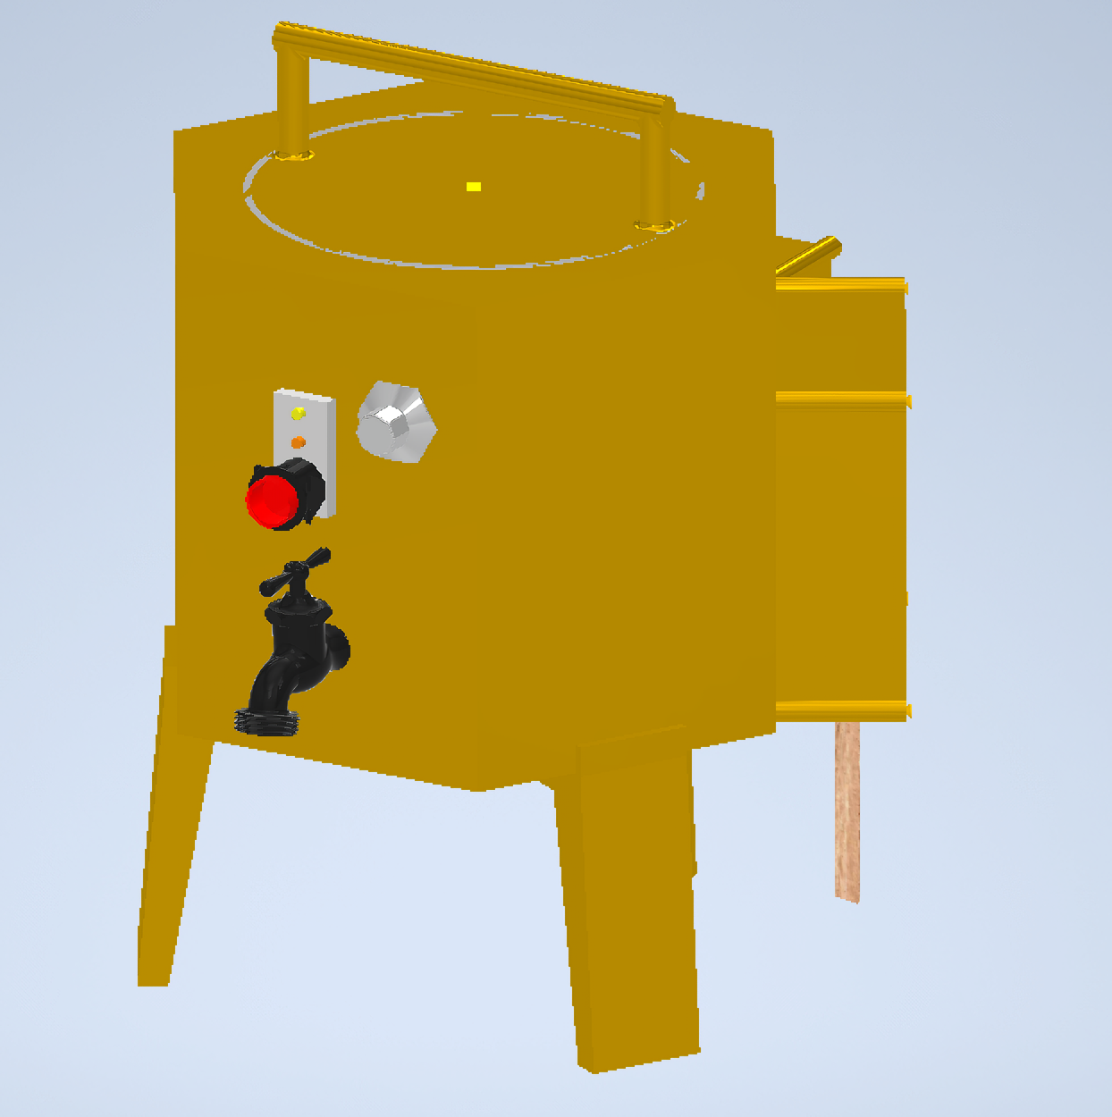

This is a machine that can be placed in any home to make candles of your own to enjoy and share with friends and family.

Who is the customer? A parent who loves candles for their home.

Wax Volume: 1 Gallon

**Design Requirements:**

1. Intended for indoor, home consumers candle making.
2. Able to pour melted wax into any candle mold desired. Should hold a gallon of wax.
3. Insulated to keep a batch of molten wax liquid for up to 4 hours.
4. Outer shell should be safe to touch during operation.
5. Should be powered by AC electricity with a 12 foot power cable.
6. Should have a controlled temperature range for wax between 200 F and 300 F.
7. Should be less than 25 lbs when empty.
8. Should have a thermally insulated, manual control valve for wax.
9. Visual notification for when it is on and when it is hot.
10. Internal metal cooking container and metal hot end nozzle must be chemical inert to most waxes.
11. Must have a simple feed or insert mechanism to optionally insert the wick, done in a second operation.
12. Should be more cost effective per candle than buying an equal volume of store bought candles (in 5 years).
13. Should be easy to clean for customer
14. The nozzle must not get clogged easily when pouring the melted wax.
15. Melting pot must hold the temperature to melt the wax

**Design Selections:**

**Edgar’s Sketch:** Wall Mounted Candle Maker

<https://www.tinkercad.com/things/4ZpfnSgwqOI-frantic-luulia/edit?sharecode=S2A3ATSwqdlovOBXc6H9YNf4GPVZWfCdQWAx5xJYl_U>

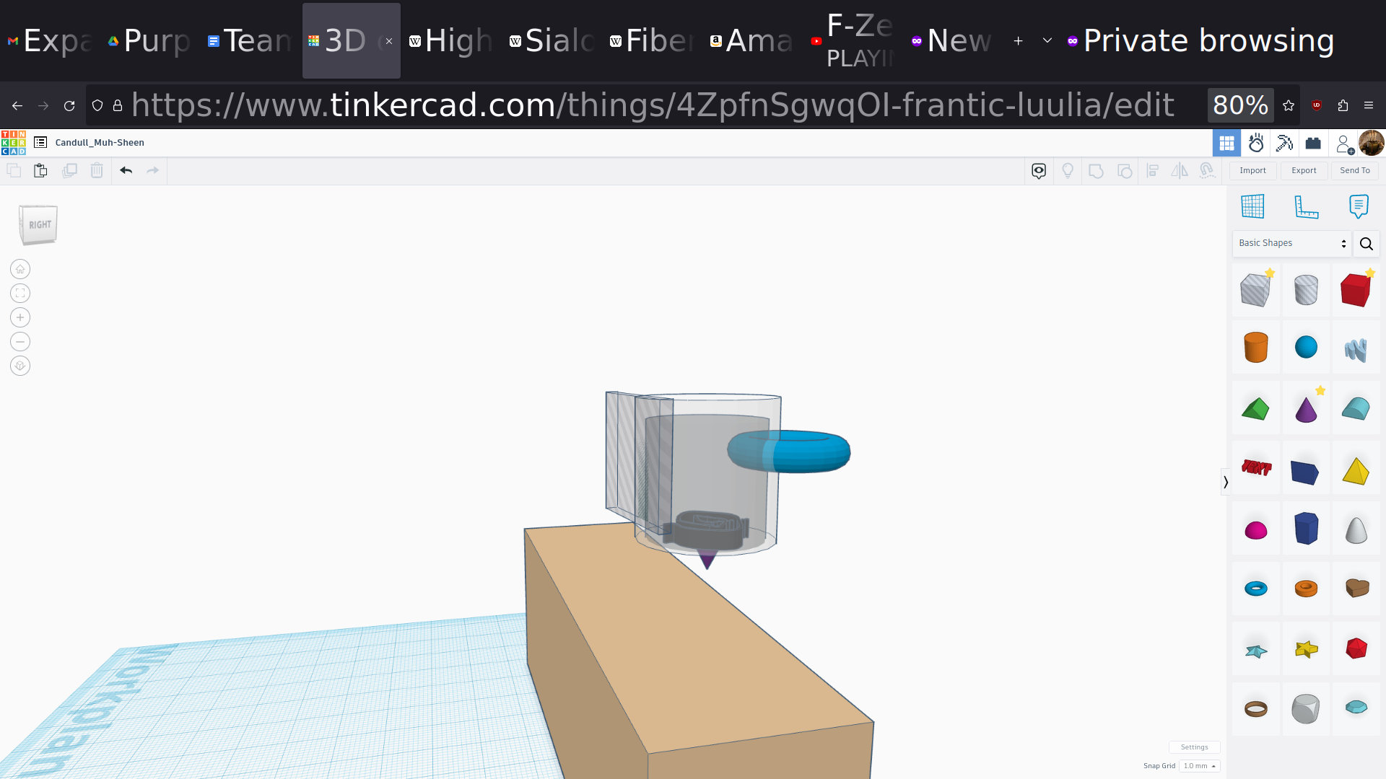

**Brenden’s Design:**

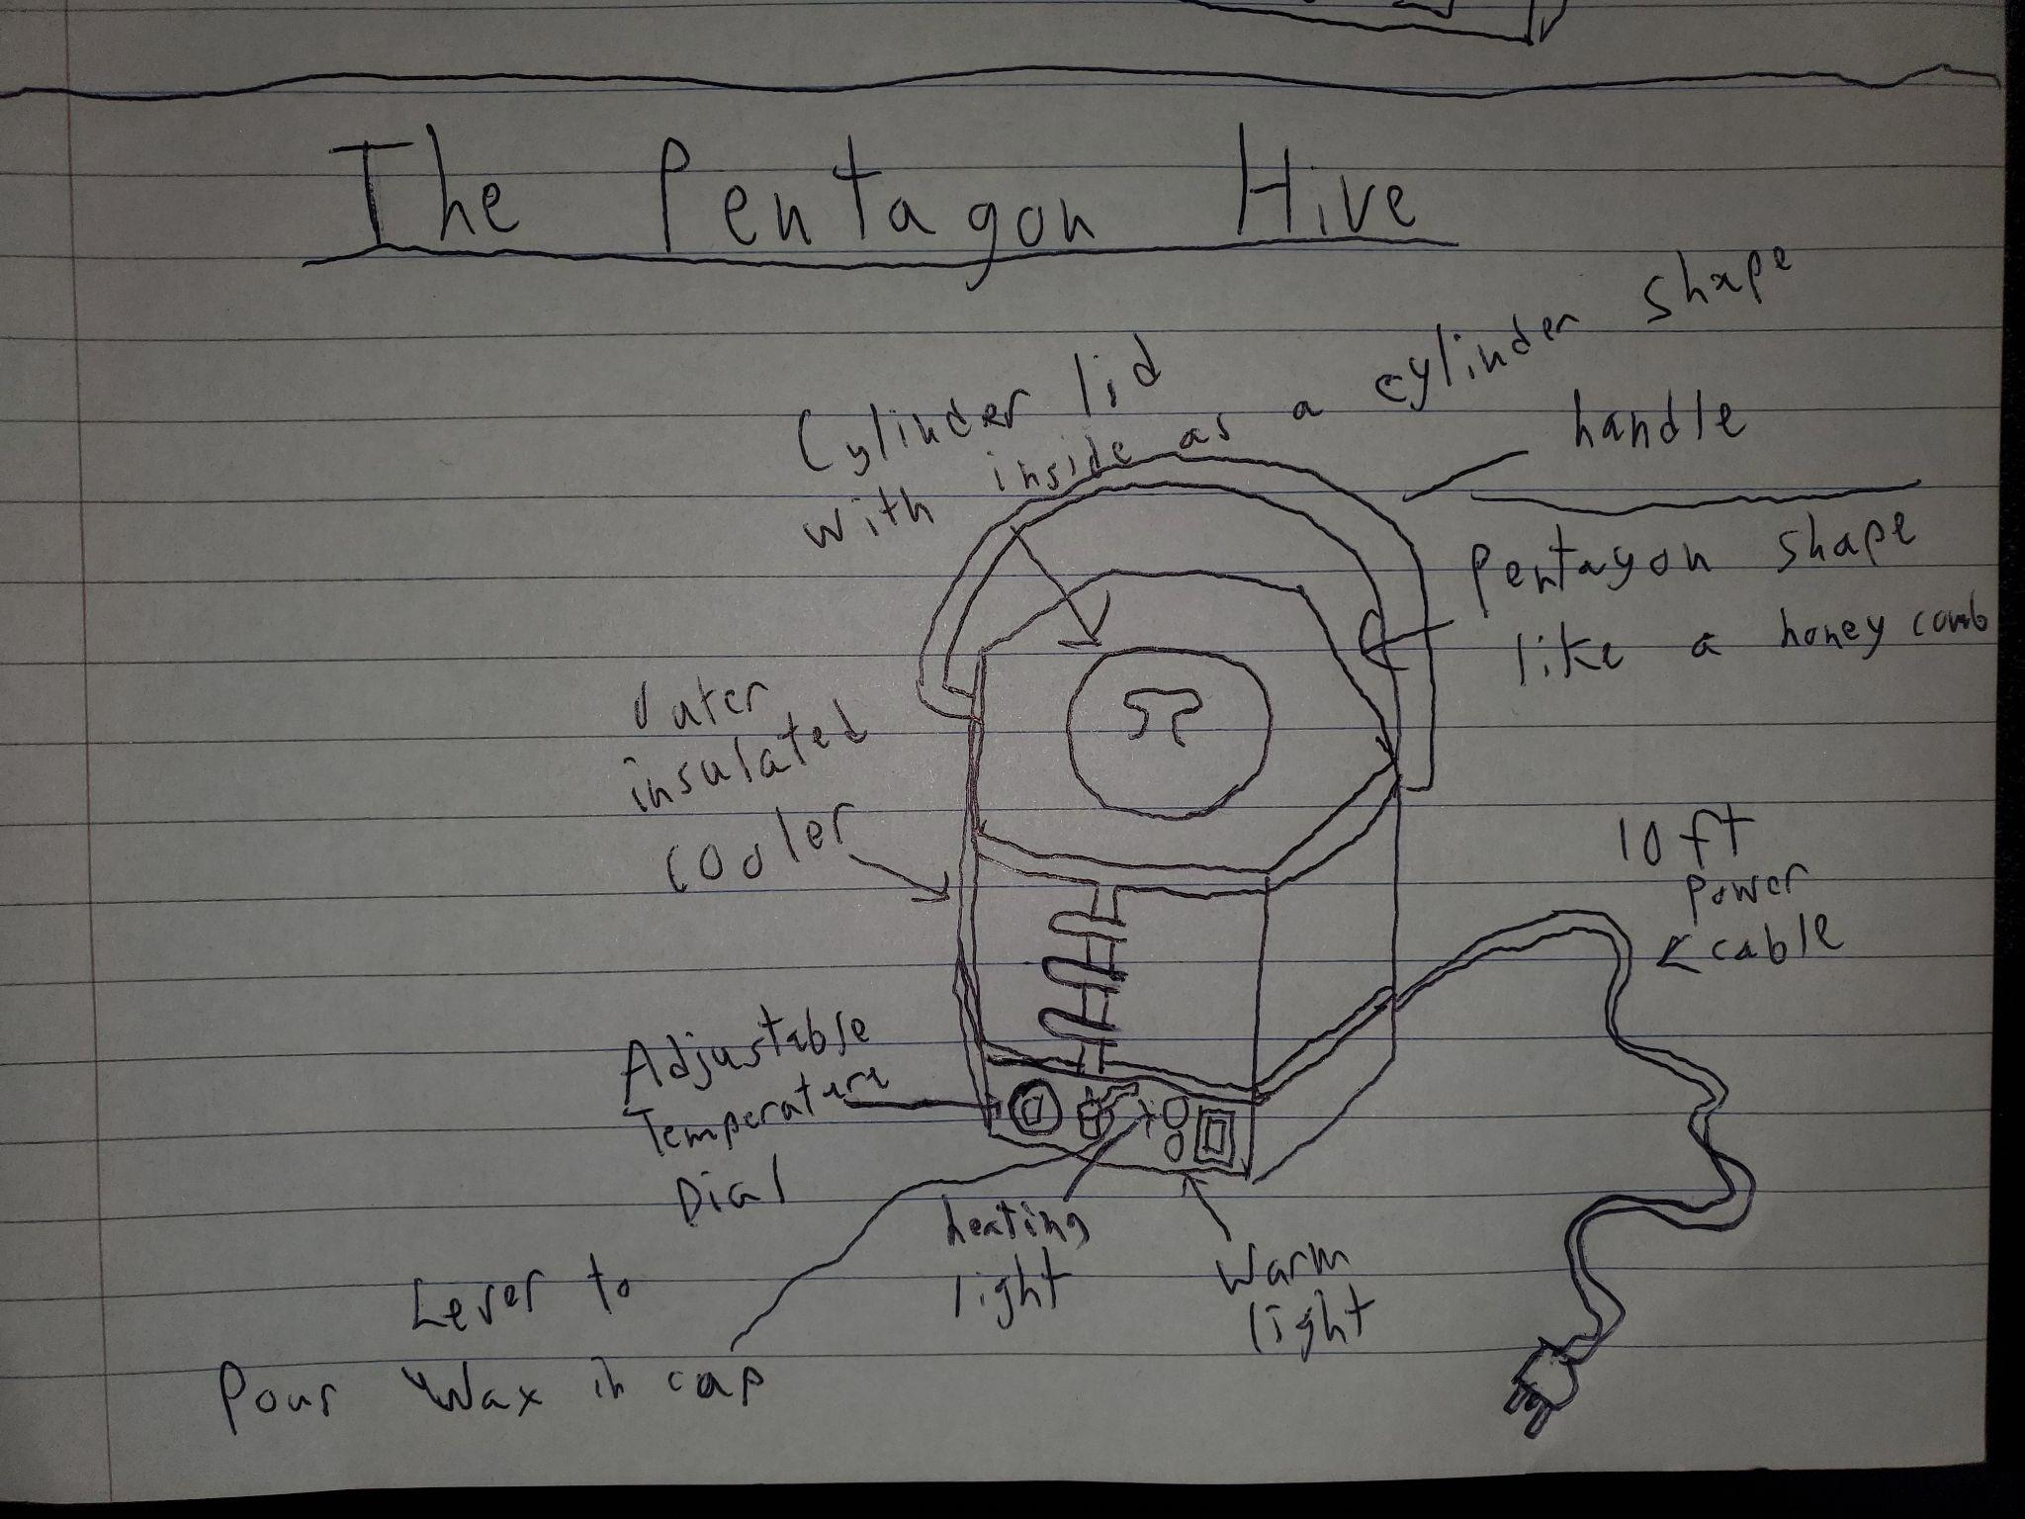

**Layout Drawing:**

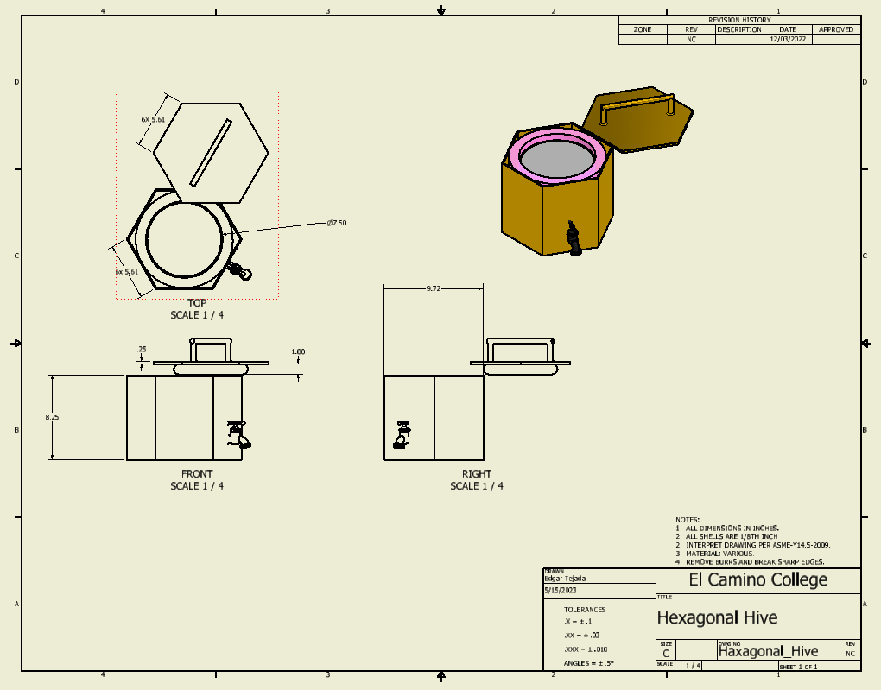

**Cost of Parts and Materials:**

| **Line Item** | **Material** | **Mass (lbmass)** | **Method of Production** | **Estimated Cost** |
| --- | --- | --- | --- | --- |
| Hexagonal Shell | Aluminum | 4.281 | Sheet Metal | $61.93 |
| Hexagonal Lid | Aluminum | 2.203 | CNC Machining | $20.00 |
| Inner Insulation | Fiberglass Foam | 0.654 | Cut and Rolled | $28.21 |
| Inner Hotpot | Aluminum | 2.56 | CNC Machining | $65.99 |
| Panel Shell | Aluminum | 0.898 | Sheet Metal | $15.48 |
| Legs (x3) | Aluminum | 2.328 | Sheet Metal | $33.68 |
| Heating Element | Magnesium Oxide Sal | 0.02 | Purchased | $3.00 |
| Rubber Stopper | Silicone Rubber | 1.757 | Cut and Rolled | $22.52 |
| DHT11 Temperature Control Chipset | Various | 0.001 | Purchased | $0.70 |
| 250 W AC-DC Power Supply | Various | 1.166 | Purchased | $9.60 |
| Buttons | Steel | 0.06 | Purchased | $0.35 |
| Lights x2 | Gallium Phosphide (GaP). | 0 | Purchased | $0.03 |
| Faucet | Acetal Plastic | 0.079 | Purchased | $6.93 |
| Temperature Dial | Aluminum | 0.006 | CNC Machining | $4.97 |
| Collet | Aluminum | 0.0590 | CNC Machining | $6.97 |
| Collet Cone | Steel | 0.0260 | CNC Machining | $1.48 |
| 6-32 UNC Screws (x12) | Steel | 0.0155 | Purchased | $0.48 |
| 7V 10W Electric Curtain Actuator | Various | 0.132 | Purchased | $4.00 |
| **Material Costs Per Unit:** | **Assuming 5000 units made** | **Total Mass (lbmass)** |  |  |
| $286.32 |  | 16.25 |  |  |

We dealt with the largest items, the metal outer shell of the product, the insulating foam, ,the metal cooking pot, and the heating element. We then listed various small items like buttons, a temperature control chip and little addons without including the wires or cost of assembly. We thought that it was gonna be less than we expected. We learned from a vendor, Xometry how some items were gonna cost more than usual like the inner hotpot for example. Just a few parts were expensive while most of the other parts were pretty cheap. We also learned that machining metal in America is very expensive.

**Candle maker concept selection:**

| Goal | **Cost** | **Size** | **Ease of Use** | **Safety** | **Durability** | **Attractive** |  | **Score** | **% Importance** |
| --- | --- | --- | --- | --- | --- | --- | --- | --- | --- |
| **Cost** |  | 1 | 0 | 0 | 1 | 0 |  | 2 | 13.33% |
| **Size** | 0 |  | 0 | 0 | 1 | 0 |  | 1 | 6.67% |
| **Ease of Use** | 1 | 1 |  | 0 | 1 | 1 |  | 4 | 26.67% |
| **Safety** | 1 | 1 | 1 |  | 0 | 1 |  | 4 | 26.67% |
| **Durability** | 0 | 0 | 0 | 1 |  | 0 |  | 1 | 6.67% |
| **Attractive** | 1 | 1 | 0 | 0 | 1 |  |  | 3 | 20.00% |
|  |  |  |  |  |  |  |  |  |  |
|  |  |  |  |  |  |  |  |  |  |
| % Importance | 13.33% | 6.67% | 26.67% | 26.67% | 6.67% | 20.00% |  |  |  |
|  |  |  |  |  |  |  |  |  |  |
| Names: Brenden Deutschman and Edgar Tejada |  |  |  |  |  |  |  |  |  |
| Project: The Hexagon Hive |  |  |  |  |  |  |  |  |  |

Ms. Ray (Brenden’s mother) would want to be able to clean pretty easily and simple to use. We also thought it would be important to have our product look nice and attractive in a kitchen for home appliances. Size and durability felt the least important mainly because the others felt more important. Though we wouldn’t want the product to b e too large and heavy for someone like Ms. Ray to move it around.

**C.S.T. Comparison Chart:**

| Goal |  | **Cost** | **Size** | **Ease of Use** | **Safety** | **Durability** | **Attractive** |  | **Score** |
| --- | --- | --- | --- | --- | --- | --- | --- | --- | --- |
| % Importance |  |  |  |  |  |  |  |  |  |
| **Wall-mounted Candle Maker (Edgar)** | Rating (1 to 10) | 3 | 4 | 7 | 5 | 7 | 6 |  |  |
|  | Score | 0.40 | 0.27 | 1.87 | 1.33 | 0.47 | 1.20 |  | 4.33 |
| **Hand-held Candle Maker (Brenden)** |  |  |  |  |  |  |  |  |  |
|  | Rating (1 to 10) | 6 | 5 | 6 | 7 | 5 | 5 |  |  |
|  | Score | 0.80 | 0.33 | 1.60 | 1.87 | 0.33 | 1.00 |  | **4.93** |
|  |  |  |  |  |  |  |  |  |  |
| Winner: |  |  |  |  |  |  |  |  |  |
| Brenden's design, Hand-held Candle Maker |  |  |  |  |  |  |  |  |  |

Winner was Brenden’s design, we will go with a hexagonal honeycomb motif since beeswax is a premium candle material. We both decided that the wall-mounted design may have used less space on the kitchen counter top, but it would be too complicated to install and wash the machine. They would most likely have to hire a guy to come and install it for them.

**Inventor Mass Break Down:**

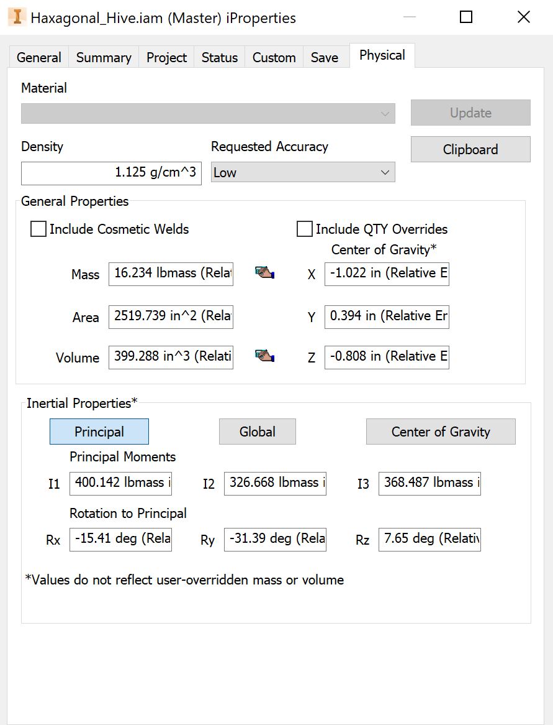

**Cost to Customer Break Down:**

Existing Candle Machine

<https://www.youtube.com/watch?v=bEhlvggbwk8>

<https://americancrafts.com/products/we-r-wick-candle-machine-kit>

$120 USD

Cost of the machine plus wax plus wicks must be less than amazon candles every two weeks for 5 years.

<https://www.amazon.com/Yankee-Candle-Studio-Medium-Coconut/dp/B0BLXJ5ZYY/ref=sr_1_2?crid=3EZCL10U2FC7J&keywords=candle&sprefix=candle%2Caps%2C126&sr=8-2>

**Price to Beat: $10/ (2 Weeks) * (5 Years) = $1303.57**

**Cost of wax:**

Mass of wax: 10 oz/ (2 Weeks) *(5 years) = 1303.57 Oz ~= **81.5 lbs of wax**

Cost of units of wax and wicks is: $25.69/5lbs <https://www.amazon.com/Hearth-Harbor-Natural-Candle-Supplies/dp/B08J1JHH5X/ref=sr_1_2?crid=3NJVF9SNR995O&keywords=soy%2Bwax%2Bfor%2Bcandle%2Bmaking&sprefix=soy%2Bwax%2Caps%2C156&sr=8-2&th=1>

Cost of Material = 81.5 lbs * ($25.69/ 5 lbs) = $418.79

Budget for Machine = Price to Beat - Cost of Material

Budget for Machine $1303.57 - $418.79 = **$884.78**

The cost of building our machine is just under $287, so it is money saving for a customer to order the Hexagonal Hive with an MSRP anywhere between $320 and $880 dollars. The optimal MSRP for profitability will be left as an exercise for the marketing department.

**Other Considerations:**

**Wick Installing Mechanism:** Some candles come with stiffer, wooden wicks. This might will easier to mechanical insert and keep still while the wax is setting.

<https://youtu.be/ocTi_xzIpz0?t=286>

Add a **collet** (camera aperture) as the wick holding and cutting mechanism?

Add legs to allow taller and wider molds for their candles/

Legs must support a high safety factor over the weight of the machine and wax

We think the legs should be five inches tall.

Notes on Collet:

Uses a bottom cone, when squeezed to a smaller cone state, tightens on held items.

<https://www.amazon.com/100pcs-Wooden-Candle-Naturally-Smokeless/dp/B07R1RYYR7?th=1>

Standard wooden wicks have a width of 0.5 inches, a 0.04 inch nominal thickness, and a height of 5.1 inches.

**Optimize the heating coil/block!**

Mass of beeswax in a gallon is over 8 lbs

[https://www.wolframalpha.com/input?i=0.96+grams+per+cubic+centimeter+*%281+gallon%29](https://www.wolframalpha.com/input?i=0.96+grams+per+cubic+centimeter+*%281+gallon%29)

Looking into the thermal properties of wax, the thermal conductivity is 0.2 W/(meter Kelvin)

And its melting point is 56 Centigrade.

See: <https://material-properties.org/wax-density-strength-melting-point-thermal-conductivity/>

Wolframalpha suggests 200W is the minimum heating coil we need to melt this much wax in under an hour. Assuming our cylinder has a surface area of 419.640 in^2

(419.640 inches^2×(0.2 W/(m K) (watts per meter kelvin difference))/(200 W/h (watts per hour)))×(56 - 20) °C (degrees Celsius) = 2760 seconds .

Results in melting the total full gallon of wax in under ¾ of an hour.

**Hexagonal Hive 2023-06-10 Parts List:**

1. Hexagonal Shell
2. Hot Pot
3. Fixed Spout
4. Mini Lights
5. Mini Lights Yellow
6. Button Panel
7. Plastic Diffuser
8. 200W Heating Coil
9. Temperature Dial
10. Hexagonal Lid
11. Rubber Stopper
12. Insulation Layer
13. Three Prong Nema Power Insert

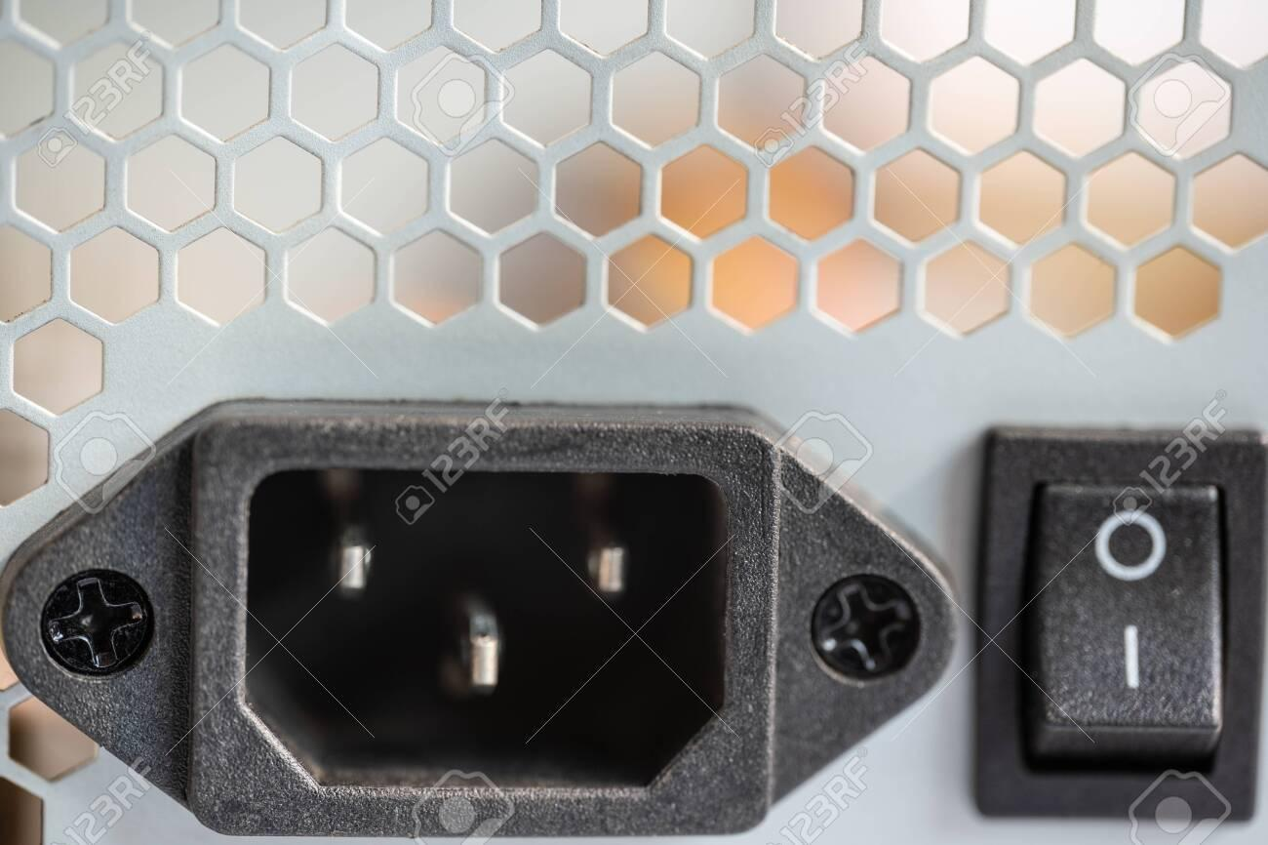

1. M4 ATX AC-DC Power Supply
2. Arduino DHT11 Temperature Controller
3. Heating Coil
4. 3x Legs
5. Wood Wick
6. Collet Cone
7. Collet Wick Cutter
8. 2x Panel Shells
9. 4x 1 in. screws 6-32 UNC thread type machine screw
10. 8x 2 in. screws 6-32 UNC thread type machine screw

**Acknowledgement of outside Models Used:**

Arduino DHT11, which acts as our temperature control for the coil and piston control for our actuator.

<https://grabcad.com/library/arduino-nano-clone-with-usb-c-1>

M4 ATX AC-DC 250W (nominal) power supply will provide DC power to the heat coil, the actuator, the DHT11 controller, and all of the lights and dials on the front panel.

<https://grabcad.com/library/computer-power-supply-mini-box-m4-atx-6-30v-250w-1>

**Final Assembly Drawing, Followed by Final Production Detail Drawings:**